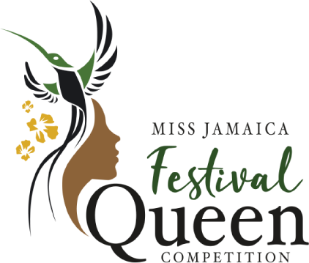
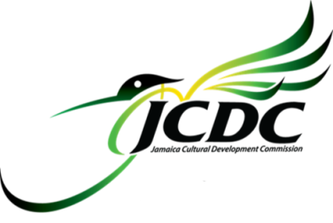

GENERAL RULES AND REGULATIONS

- Contestants must be citizens of Jamaica and aged eighteen to twenty-five (18-25) years, before the National Coronation.
- Contestants must have been born in the Parish from which they entered or must have been residing in that Parish for a period of not less than six (6) months prior to the Parish Coronation.
- Applications from Contestants who were placed in the top three (3) of the previous year of this competition will not be accepted.
- Applications from Contestants who have won at the Parish and/or National level will not be accepted.
- If a contestant who is crowned at the Parish level is unable to participate at the National level if for any reason, a letter is required of her to relinquish the crown. In such an instance, the first runner up will assume the duties and role of the Parish Queen.
- Contestants who wish to participate in the Miss Jamaica Festival Queen Competition must perform a cultural item from the areas of Dance, Music, Speech, Drama, Traditional Folk Forms or a combination of any at Parish and National Coronation.
- All Contestants are allowed a maximum of two (2) minutes for performance. Five (5) points will be deducted thereafter.
- Each Contestant must identify and be actively involved with an ongoing community project for at least six (6) months.
- The Jamaica Cultural Development Commission reserves the right to request a medical examination by a certified Medical Practitioner.
- The Jamaica Cultural Development Commission will not be held responsible for loss or damage of any personal belongings of contestants, however caused, during their participation in the contest.
- Contestants shall be unmarried, not living in a common-law relationship and should not be a mother.
- The Jamaica Cultural Development Commission reserves the right to approve, amend or reject each participant's item for performance in the competition.
- The Jamaica Cultural Development Commission reserves the right to contract within its discretion for sponsorship of any or all contestants, and contestants must agree to accept and represent any such sponsor.
- The Jamaica Cultural Development Commission will not be responsible for expenses incurred by contestants unless such expenses were previously authorized by the Commission’s representative.
- No sponsor is obligated to assist a Contestant/Queen beyond any sponsorship fees/arrangement paid to the Jamaica Cultural Development Commission.
- No Contestant/Queen is allowed to contact a sponsor directly or through a third party, except through the Jamaica Cultural Development Commission.
- During the competition, any Contestant who leaves the official residence provided for Contestants or the official Festival Queen party, or accepts private engagements without the permission of the Commission, will be liable for disqualification.
- The gown to be worn by each Contestant on the final night of the competition must be presented to the respective Committee for approval seven (7) days before the Coronation. This must be done both at the Parish and National levels.
- The Parish committees will approve clothing for finalists for the National judging functions. There will be fixed wardrobe based on planned events.
- Accommodation, meals and transportation during the Residency period of the National Coronation will be the responsibility of the Jamaica Cultural Development Commission.
- No application will be accepted from persons involved in any beauty, modeling or any other such pageant, if the final of this competition is scheduled to take place within a three (3) months period prior to or after the selection of the Miss Jamaica Festival Queen finalists.
- The Jamaica Cultural Development Commission reserves the right to appoint its panel of adjudicators at all levels of the competition.
- The decision of the Judges shall be final and binding at all levels of the competition.

RULES FOR THE NATIONAL/PARISH QUEEN

- The Parish Festival Queen and the Miss Jamaica Festival Queen shall reign until her successor is selected, and shall crown her successor at the next Festival Queen Competition, unless for any reason the title is withdrawn.
- Miss Jamaica Festival Queen will be required to represent Jamaica in Local/International Pageants at the discretion of the Jamaica Cultural Development Commission. Should Miss Jamaica Festival Queen be unable to participate in the Local/International Pageant(s), the Jamaica Cultural Development Commission reserves to right to select any of the runners-up or a reigning Parish Queen to do so.
- The Jamaica Cultural Development Commission shall be responsible to appoint Chaperones for all official functions and shall approve itineraries for all official overseas trips arriving out of the competition. It will be the duty of the recipient of any such engagements to cooperate with Chaperones and the Commission at home and abroad.
- Miss Jamaica Festival Queen/ Parish Festival Queen must notify the Jamaica Cultural Development Commission before undertaking personal overseas trips during their reign.
- The Jamaica Cultural Development Commission will liaise with groups or individuals for invitations to the Queen and reserves the right to approve or reject all or any request.
- Miss Jamaica Festival Queen/Parish Queen shall be required to identify, launch and implement/work with community project, which might be an ongoing project in consultation with the Committee, during her reign. Reports must be submitted at specified intervals.
- Miss Jamaica Festival Queen, during the year of her reign, shall obtain in writing the approval of the Jamaica Cultural Development Commission before committing to do any form of advertising.

CONDITIONS FOR DISQUALIFICATION

8a. The Commission reserves the right to disqualify any contestant at any time during the competition without publicizing its reason (s).
8b. The marriage or pregnancy of Miss Jamaica Festival Queen during her reign, a period of one (1) year.
9a. If Miss Jamaica Festival Queen, during her reign, commits any breach of these rules or should be involved in any act or conduct which the Jamaica Cultural Development Commission deems unbecoming or tarnishes the image of the Commission, the Commission shall declare the title forfeited and she shall relinquish her titles and all privileges attached thereto.
9b. In the event the title of Miss Jamaica Festival Queen is forfeited, the Commission may confer the title upon the runner-up in the competition.
10. The Commission reserves the right to disqualify any Contestant who gives gifts/package or aids in persuading any adjudicator to sway a decision in their favour.

ASSIGNMENT OF RIGHTS

The applicant hereby assigns to the Jamaica Cultural Development Commission the exclusive worldwide rights to make and commercially exploit images, audio-visual and sound recordings of the applicant's entry and/or performances rendered in the course of this competition. This assignment shall include the right to make and distribute mechanical audio- visual, sound and image carriers such as videos, DVD, and compact discs as well as the rights to broadcast on radio, television and the internet.

WARRANTIES

The applicant hereby warrants and represents that she is duly authorized to grant the rights above mentioned and hereby agrees to indemnify and hold the JCDC harmless from and against all claims that may arise from third parties as a consequence of the rights granted to the JCDC. The applicant agrees to execute such other agreements as may be necessary to give effect to the undertakings herein mentioned.

Entrants are asked to download the Miss Jamaica Festival Queen entry form from www.jcdc.gov.jm, complete and submit to their parish office or complete the fillable entry form via our online platform.

